Announcements

***Church after Church:*** Please join us for *Church After* *Church* in Norman Barnett Hall.

***Children’s Worship:*** 3, 4, & 5 year olds are invited to leave after the Children’s Sermon for a special Worship time.

***Prayer Request Cards*** are located in the Narthex and on the table by the Elevator

***Administrative Council*** will meet next Sunday, March 10th at 11:30 in Norman Barnet Hall following Church After Church. 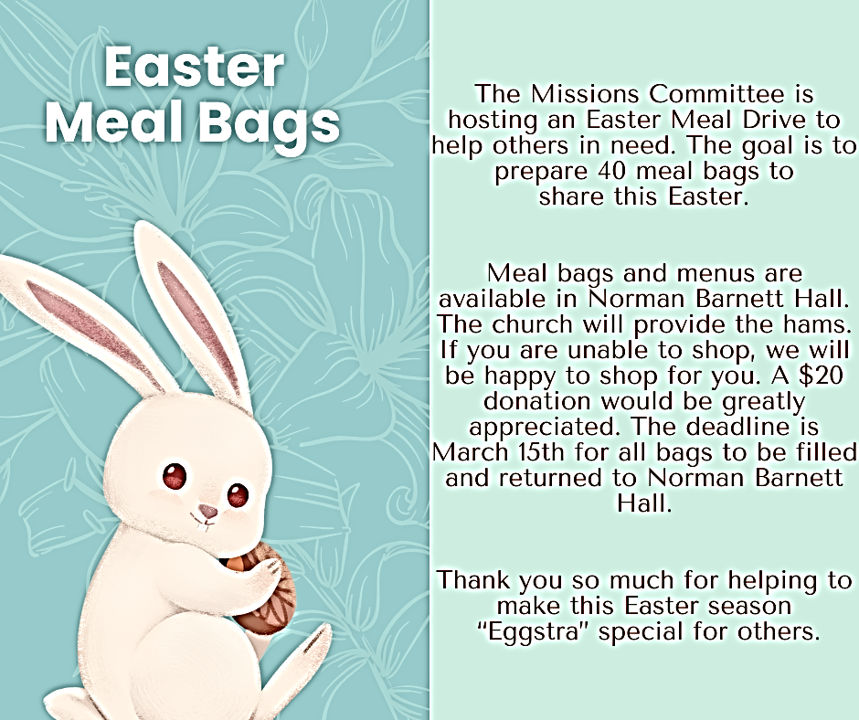

`

***Bridal Shower*** for Lauren Fuqua, bride elect of Griffin McKenzie is on March 10th from 1:30 – 3:00 in Wesley Hall.

***Time Changes next Sunda*y!** Don’t forget

“spring forward” by turning your clocks ahead one hour before going to bed on Saturday night.

*Sympathy is extended to the family of* ***Jim Kane***

*who passed away on*

*February 26, 2024*

Dearest FUMC Family, Words cannot express how much the Dunns appreciate the outpouring of love and support that our church family poured over our family throughout Tristin and Emily’s engagement and now wedding. What an awesome foundation on which to start a marriage. Thank you all from the bottom of our hearts for loving our family like you do.

Wally and Christi Dunn

**February Giving**

**Received:** $ 26,042.00

**Needed:** $ 39,688.00

**YTD Giving**

**Received:** $ 52,610.35

**Needed:** $ 79,376.00

***CURRENT BIBLE STUDIES***

We are called to be in the Word.

Please consider attending one of the following . . .

Sundays 5:00 pm Pastor Johns Bible Study (Alice Lee Room)

Wednesdays 10:00 am Ladies Bible Study (NBH )

4:15 pm Youth Bible Study (NBH )

5:15 pm Ladies Bible Study (NBH )

First United Methodist Church

324 Pineville Road

Monroeville, Alabama 36460

251-575-2790

March 3, 2024



**Church Staff**

Senior Pastor: Rev. John Woodrow

Minister of Education: Rev. Pam Barnhardt

Director of Music Ministries/Organist: Nancy Carleton

Church Business Administrator: Caroline Hardin

Nursery Director: Christi Dunn

Nursery Attendants: Letitia Gibbs & Rosie Parker

**Morning Worship**

March 3, 2024 ‡ 10:05

**Third Sunday in Lent**

**Holy Communion**

**ENTRANCE**

Gathering Prelude Nancy Carleton  *Welcome and Opportunities* Rev. Pam Barnhardt

Invocation Rev. Barnhardt

† Hymn 376 *There Is a Balm in Gilead* Congregation

† The Apostle’s Creed Congregation

I Believe in God, the Father Almighty, maker of Heaven and earth;

And in Jesus Christ his only Son, our Lord;

Who was conceived by the Holy Spirit, born of the Virgin Mary,

suffered under Pontius Pilate, was crucified, dead, and buried;

the third day he rose from the dead; he ascended into heaven,

and sitteth at the right hand of God the Father Almighty;

from thence he shall come to judge the quick and the dead.

I Believe in the Holy Spirit, the holy catholic church, the communion of saints,

the forgiveness of sins, the resurrection of the body, and the life everlasting. Amen

† The Gloria Patri Congregation

**PROCLAMATION and RESPONSE**

Prayer of Confession Congregation

Most merciful God, we confess that we have sinned against you

in thought, word, and deed,

by what we have done, and by what we have left undone.

We have not loved you with our whole heart;

we have not loved our neighbors as ourselves.

We are truly sorry and we humbly repent.

For the sake of your Son Jesus Christ, have mercy on us and forgive us;

that we may delight in your will and walk in your ways

to the Glory of Your name. Amen

Assurance of Pardon Rev. Woodrow

Offering Nancy Carleton

† Doxology *Praise God from Whom All Blessings Flow* Hymnal, 95

† Hymn *As the Deer* Congregation

*(Let the children come forward during the last stanza)*

As the deer panteth for the water, so my soul longeth after you;

You alone are my heart’s desire, and I long to worship you.

***(Refrain)*** You alone are my strength and shield; to you alone may my spirit yield.

You alone are my heart’s desire, and I long to worship You.

You’re my friend and you are my brother, even though you are a King

I love you more than any other, so much more than anything! ***(Refrain)***

I want you more than gold or silver, only You can satisfy

You alone are the real joy-giver and the apple of my eye. ***(Refrain)***

Children’s Moment Rev. Barnhardt

*(After Children’s Moment 3-5 year olds are invited to go to Children’s Worship)*

Anthem  *Turn Your Eyes Upon Jesus* Chancel Choir

Scripture  *Mark 8: 27-33* Rev. Woodrow

Sermon “*Reshaping God*”Rev Woodrow

**THANKSGIVING and COMMUNION**

The Great Thanksgiving Hymnal, p.13

The Lord’s Prayer Hymnal, 895

Blessing of the Elements Pastor

Sharing the Elements Pastors

Prayer of Thanks Pastor

**SENDING FORTH**

† Hymn 2130 (TFWS) *The Summons* Congregation

† Benediction Rev. Woodrow

† Three-fold Amen Congregation

Going Forth *Postlude* Nancy Carleton

__________________________________________________________________________________

† *Standing as able Please silence or turn off your cell phones.*

**Attendance registration August 13, 2017**

Check one: 9:00_____11:00_____

Name___________________________

Address_________________________

Phone__________________________

Email___________________________

* Member(s)
* First time visitor
* Visitor
* Wish to join church
* Desire pastoral visit

Will you share your birthday below for our newsletter birthday list?

_______________________________

Acolyte: Marlee Kate Farish

*The Altar Flowers today are given to the greater glory of God*

*and*

*by Cecelia Ingram/Pam Barnhardt.*