Announcements

Prayer Request Cards are located in the Narthex and on the table by the Elevator
Congratulations! We welcome Mr. Preston Baker Barnett, Sr. as our newest professing member of Monroeville FUMC. Preston is a longtime supporter of the church and has made his membership official.
Office Christmas Hours: Closed on December 25th and January 1st Abbreviated Hours 9 – 12 on December 21 and 26 – 28
December Giving Received: $ 35,435.00 Needed: $ 39,688.00

YTD Giving Received: $ 372,774.50 Needed: $ 476,256.00

Year End Contributions
Please have all gifts to First United Methodist Church to the business office by 12:00 Noon on Thursday, December 28th.

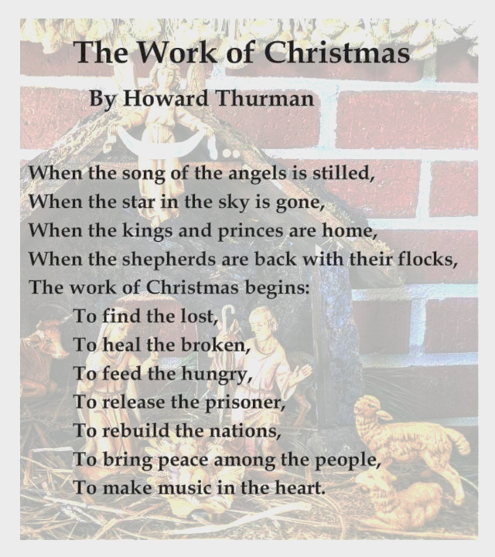

First United Methodist Church
324 Pineville Road
Monroeville, Alabama 36460
251-575-2790

December 24, 2023

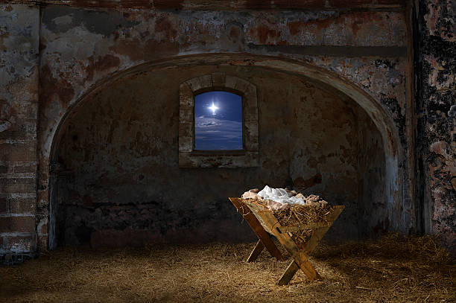

Church Staff

Senior Pastor: Rev. John Woodrow
Minister of Education: Rev. Pam Barnhardt
Director of Music Ministries/Organist: Nancy Carleton
Church Business Administrator: Caroline Hardin
Nursery Director: Christi Dunn
Nursery Attendants: Letitia Gibbs & Rosie Parker

Morning Worship
December 24, 2023 ‡ 10:05
Christmas Eve

ENTRANCE

Gathering Prelude Nancy Carleton Welcome and Opportunities Rev. Pam Barnhardt
Invocation Rev. Barnhardt
Lighting the Advent Wreath Candle of Love The Ard Family
Presentation of Christmas Ornaments Rev. Barnhardt
Offering Nancy Carleton
† Doxology Praise God from Whom All Blessings Flow Hymnal, 95
† Hymn 220 Angels from the Realms of Glory Congregation
Children’s Sermon Rev. Barnhardt
Scripture John 1:6-8, 20-26 Rev. John Woodrow
Homily “Christ Among Us” Rev. Woodrow

Favorite Memories, Favorite Hymns

Hymn 245 The First Noel Congregation
† Benediction Rev. Woodrow
† Three-fold Amen Congregation
________________________________________________________________________________________________

† Standing as able Please silence or turn off your cell phones.

Opportunities for the Week
Sunday, December 24 Christmas Eve
9:00 am Sunday School
4:30 pm Chancel Bells Christmas Program (Sanctuary)
5:00 pm Communion & Candlelight Service (Sanctuary)
7:00 pm Communion & Candlelight Service (Sanctuary)
Monday, December 25 Christmas Day - Church Office Closed

Tuesday, December 26 Office Hours 9 - 12

Wednesday, December 27 Office Hours 9 - 12

Thursday, December 28 Office Hours 9 - 12

Friday, December 29

Saturday, December 30

Sunday, December 31
9:00 am Sunday School
10:05 am Worship Service (Sanctuary)
- No Evening Activities -

CELEBRATING BIRTHDAYS THIS WEEK

Lindsey Coxwell Sarah Dyess

PRAYER CONCERNS
Pray for one another that you may be healed . . . James 5:16

NEW THIS WEEK Anne Pickens Jane Bouler Cile Coaker

FROM OUR CHURCH Cecelia Ingram Mary Ann Brown Norma James Jim Kane Carter English Roy and Jeannette Adams Sue Sellers

GLOBAL CONCERNS

FRIENDS & FAMILY MEMBERS Neil Dobson Mike Edward Sherry Knighten Kaitlyn Tillman Meda & Larry Keefer Jack Adams Anne Pickins Shari Bryan Valerie Stevens
Katherine Gantt (Debra Morgan’s Mother) Sandy Downing Evalen Thomas

Please note our prayer request policy:
We cannot publish a prayer request if the person making the request has not signed the attendance form on which it is submitted.

Prayer requests will be published for 3 months unless requested otherwise.

Names in italics indicate long term needs.

It is not the intention of the staff to remove any who remain in particular need of prayer. If this occurs, please let us know so that it can be corrected.

You may add or remove names from the prayer list at any time by using the Prayer Concerns cards in the pews and placing it in the offering plate or by calling the church office.

Attendance registration August 13, 2017
Check one: 9:00_____11:00_____
Name___________________________
Address_________________________
Phone__________________________
Email___________________________
- Member(s)
- First time visitor
- Visitor
- Wish to join church
- Desire pastoral visit
Will you share your birthday below for our newsletter birthday list?
_______________________________

Email: FUMC324@gmail.com
www.firstumcmonroeville.org Facebooklive: MonroevilleFumc-Youth

The Altar Flowers today are given to the greater glory of God
and
by Cecelia Ingram/Pam Barnhardt.

