Morning Worship
December 10, 2023 ‡ 10:05
Second Sunday of Advent

ENTRANCE

Gathering O Come, O Come Emmanuel Nancy Carleton Welcome and Opportunities Rev. John Woodrow
Invocation Rev Woodrow
Lighting the Advent Wreath Family of Layla Daniels
Candle of Love
Celebrations and Concerns Rev. Woodrow
Pastoral Prayer
Offering Nancy Carleton
† Doxology Hymnal, 95
Praise God from Whom All Blessings Flow

The Glory of Christmas
By Lloyd Larson

Introduction

The Glory of Christmas
Congregation is asked to join the choir in singing. . .
Angels We Have Heard on High
Angels we have heard on high sweetly singing o’er the plains,
And the mountains in reply echo back their joyous strains.
Gloria in excelsis Deo! Gloria in excelsis Deo!

Narration 1: The Hope of Christmas
Keep Your Lamps Trimmed and Burning
Narration 2: The Promise of christmas
Prepare the Way of the Lord!
Narration 3: The Wonder of Christmas
Child of Promise, Child of Love

Narration 4: the Majesty of Christmas
Jesus Is Born Tonight!

Congregation is asked to join the choir in singing. . .
Hark! The Herald Angels Sing
Hark! The herald angels sing, “Glory to the newborn King;
Peace on earth, and mercy mild, God and sinners reconciled!”
Joyful, all ye nations rise, join the triumph of the skies; with th’angelic host proclaim,
“Christ is born in Bethlehem
Hark! The herald angels sing, “Glory to the newborn King!”
Hail the heav’n born Prince of Peace! Hail the Sun of righteousness!
Light and life to all He brings, ris’n with healing in His wings.
Mild he lays His glory by, born that we no more may die,
born to raise us from the earth, born to give us second birth.
Hark! The herald angels sing, “Glory to the newborn King!”

Narration 5: The Mystery of Christmas
Christ Is Born This Holy Night

Narration 6: The Brilliance of Christmas
Guide Us to the Perfect Light

Narration 7: The Glory of Christmas
The Glory of Christmas!
Congregation is asked to join the choir in singing. . .
O Come, All Ye Faithful
O Come, all ye faithful, joyful and triumphant,
O come ye, O come ye to Bethlehem!
Come and behold Him, born the King of angels!
O come, let us adore Him,
O come let us adore Him,
O come, let us adore Him, Christ the Lord!
Sing, Choirs of angels, sing in exultation!
O sing, all ye citizens of Heav’n above!
Glory to God, all glory in the highest!
O come, let us adore Him,
O come, let us adore Him,
O come, let us adore Him, Christ the Lord!

SENDING FORTH

† Benediction Rev. Woodrow
† Three-fold Amen Congregation
Going Forth Postlude Nancy Carleton
______________________________________
† Standing as able Please silence or turn off your cell phones.

Chancel Choir and Friends

Soprano
Anna Claire Bradley Nina Lazenby
Melody Bradley Emilie Martin
Sherry Daniels Stacey McKenzie
Carole Dean Diane Watson
Belinda Dorrance Joy Whetstone
Elise Wiggins

Alto
Lindsey Coxwell Laura King
Susannah Dorrance Sammye Long
Barb Heinzen Caroline Sonen
Kathy Johnson Fredia Tatum
Rosemary Johnston Haden Tirey
Melanie Woodrow

Tenor
Al Brewton Shannon McKenzie
Rev. John Woodrow

Bass
Danny Brittingham Hub Broughton
Mike Stoops

Narrator
Mark Johnson

The Cantata today is given to the glory of God
in memory of Janice A. Kane and in honor of Jim Kane
with thanks for his support of the Chancel Choir.

PRAYER CONCERNS
Pray for one another that you may be healed . . . James 5:16

NEW THIS WEEK

FROM OUR CHURCH Cecelia Ingram Mary Ann Brown Norma James
Jim Kane Carter English Roy & Jeannette Adams Sue Sellers

GLOBAL CONCERNS

FRIENDS & FAMILY MEMBERS Neil Dobson Mike Edwards Sherry Knighten Kaitlin Tillman Meda & Larry Keefer Jack Adams Anne Pickens Shari Bryan Valerie Stevens Martha Jordan Sandy Downing
Katherine Gantt (Debra Morgan’s Mother) Evalen Thomas

Please note our prayer request policy:
We cannot publish a prayer request if the person making the request has not signed the attendance form on which it is submitted.

Prayer requests will be published for 3 months unless requested otherwise.

Names in italics indicate long term needs.

It is not the intention of the staff to remove any who remain in particular need of prayer. If this occurs, please let us know so that it can be corrected.

You may add or remove names from the prayer list at any time by using the Prayer Concerns cards in the pews and placing it in the offering plate or by calling the church office.

Opportunities for the Week
Sunday, December 10 Second Sunday of Advent
9:00 am Sunday School
10:05 am Worship Service (Sanctuary)
11:00 am Church after Church (Norman Barnett Hall)
5:00 pm Pastor John’s Bible Study (Alice Lee Room)
5:00 pm Youth/Children (Norman Barnett Hall)

Monday, December 11
1:00 pm Sewing Group (Norman Barnett Hall)
6:00 pm AA Meeting (Room 404)

Tuesday, December 12
10 am – 12:30 pm HIPPY (Wesley Hall)

Wednesday December 13
6:45 am Youth Prayer Breakfast (Norman Barnett Hall)
9:00 am Wednesday Men (Norman Barnett Hall)
10:00 am Women’s Bible Study (Norman Barnett Hall)
4:15 pm Youth Bible Study (Norman Barnett Hall)
4:30 pm Chancel Bells (Bell Room)
5:15 pm Women’s Bible Study (Norman Barnett Hall)

Thursday, December 14
5:00 – 7:00 pm Alabama Mentors (Norman Barnett Hall)

Friday, December 15

Saturday, December 16

Sunday, December 17 Third Sunday of Advent
9:00 am Sunday School
10:05 am Worship Service (Sanctuary)
11:00 am Church after Church (Norman Barnett Hall)
5:00 pm Youth/Children (Norman Barnett Hall)

CELEBRATING BIRTHDAYS THIS WEEK
Kay Dobson Carole Dean Kay English
Sammie Carter Max Carter

Email: FUMC324@gmail.com
www.firstumcmonroeville.org Facebooklive: MonroevilleFumc-Youth

Announcements

A Heartfelt Thank-You from the Children for your generous gifts to the White Christmas Offering last Sunday which totaled $3,973.00. Donations will still be received through the rest of December.
Church after Church: Please for Church After Church in Norman Barnett Hall.
Children’s Worship: 3, 4, & 5 year olds are invited to leave after the Children’s Sermon for a special Worship time.
Prayer Request Cards are located in the Narthex and on the table by the elevator
Missions Committee to Host Bake Sale today during Church After Church. This will benefit the Children’s Home.
Pastor John’s Bible Study will meet this evening for the last time this year. This Bible Study will resume on January 7th.
UMYF Monroeville Merri Mail Christmas Card drop-off and pick up is ready to go for folks we see at First UMC. Donations to this project support Youth Ministries.
December 28th is the last day for deposits to post to 2023. Please be sure to get end of year giving in no later than Noon on the 28th.
Honey Baked Hams: Youth are still taking orders. Delivery date will be December 20th.

Continuing through Advent
December 17 Third Sunday of Advent Poinsettia Sunday
Ornaments presented to babies born this year
December 24 Fourth Sunday of Advent Christmas Eve
Morning Worship at 10:05
4:30 pm Chancel Bells Chistmas Program
5:00 and 7:00 pm Christmas Eve Communion & Candlelight Services
December 31 First Sunday After Christmas

December Giving Received: $ 10,878.00
December Giving Needed:
$ 39,688.00
______________________________________________

YTD Giving Received:
$ 348,217.50
YTD Giving Needed:
$ 476,256.00

YOU ARE CORDIALLY INVITED
TO A PORTRAIT DEDICATION
HONORING
Dr. Jack Whetstone
Sunday, December 10, 2023
2:00 pm

Monroe County Hospital
2016 S. Alabama Avenue
Monroeville, AL 36460

First United Methodist Church
324 Pineville Road
Monroeville, Alabama 36460
251-575-2790

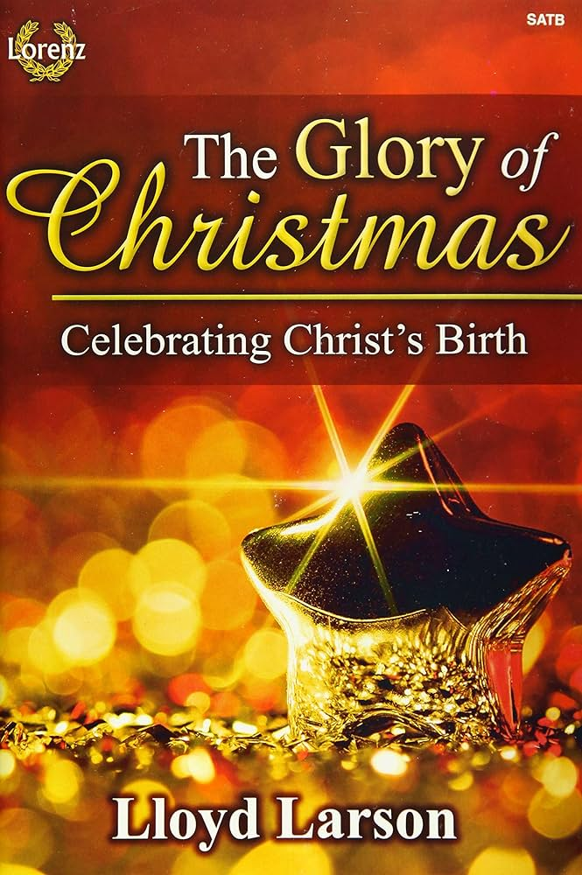

Church Staff

Senior Pastor: Rev. John Woodrow
Minister of Education: Rev. Pam Barnhardt
Director of Music Ministries/Organist: Nancy Carleton
Church Business Administrator: Caroline Hardin
Nursery Director: Christi Dunn
Nursery Attendants: Letitia Gibbs & Rosie Parker

December 10, 2023

