Announcements

***White Christmas Sunday*** : White Christmas Offering will be taken today during worship. Please come forward to leave your gift when the month of your birthday is named.

***Chancel Choir Rehearsal*** will be on Monday, December 5th and on Wednesday December 7th at 5:30 pm in the Sanctuary.

**Chancel Choir will present** “Sing a Song of Christmas” next Sunday, December 11th during Worship. There will be a **Fellowship Brunch** in Wesley Hall following the service. The Church will provide baked ham. **Please bring** **sides and desserts**.

***Prayer Request Cards*** may be found in the pews as well as in the Narthex and on the table by the Elevator. To have someone placed on the prayer list, please fill out the card and place in the offering plate. Cards may be used to let the staff know about upcoming procedures. You may also call the church office or send an email to the church.

***Honey Baked Hams*** – Youth are still taking orders. Projected delivery will be on December 16th.

***Church after Church*** will **NOT** take place on December 11th, due to Fellowship Brunch. It will also **NOT** take place on December 25th or January 1st.

**Continuing through Advent**

December 11 **Third** Sunday of Advent Poinsettia Sunday

**Chancel Choir Cantata** during Worship

**Fellowship Brunch** in Wesley Hall following Worship

December 18 **Fourth** Sunday of Advent

December 24 Saturday, **Christmas Eve**

**4:30** pm **Chancel Bells Chistmas Program**

**5:00** and **7:00** pm **Christmas Eve Communion & Candlelight Services**

December 25 **Christmas Day Worship at 10:05**

First United Methodist Church

324 Pineville Road

Monroeville, Alabama 36460

251-575-2790

December 4, 2022



**Church Staff**

Senior Pastor: Rev. John Woodrow

Minister of Education: Rev. Pam Barnhardt

Director of Music Ministries/Organist: Nancy Carleton

Church Business Administrator: Caroline Hardin

Nursery Director: Christi Dunn

Nursery Attendants: Letitia King & Rosie Parker

**Morning Worship**

December 4, 2022 ‡ 10:05

**Second Sunday of Advent**

**White Christmas Sunday**

**ENTRANCE**

Gathering Prelude Nancy Carleton  *Welcome and Opportunities* Rev. Pam Barnhardt

Invocation Rev. Barnhardt

Lighting the Advent Wreath *Candle of Peace* Boyd Robinson Family

Offering Nancy Carleton

† Doxology Praise God from Whom All Blessings Flow Hymnal, 95

† Hymn 229 *Infant Holy, Infant Lowly* Congregation

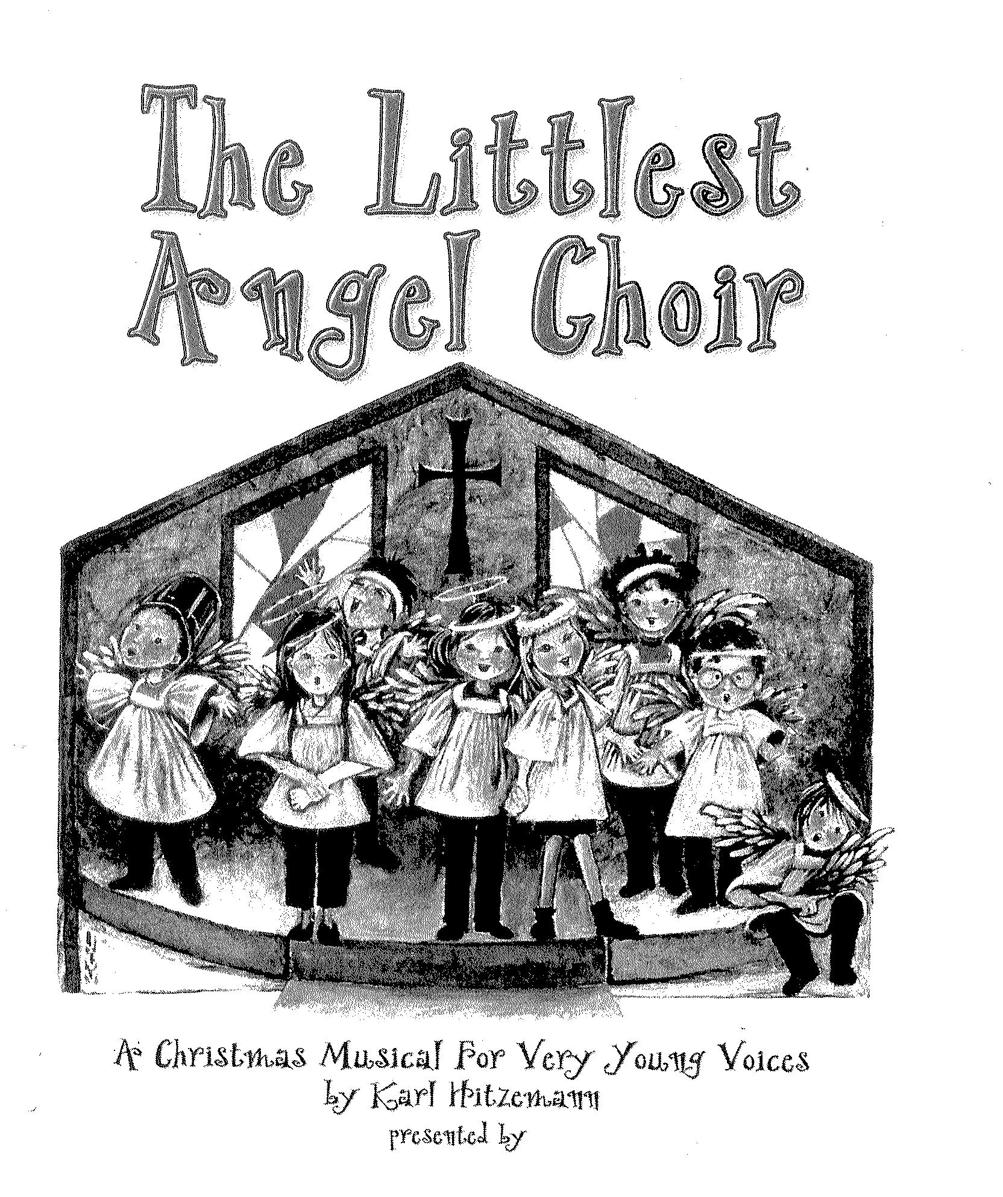

***Our Wonderful Story***

***Where Do We Fit In?***

***God Is on Our Side***

***Silent Night***

(Congregration is asked to join in singing as we repeat the first verse.)

***Hear the Angels Sing***

Children’s Sermon Rev. Barnhardt

**CAST**

Narrators: Anna Claire Bradley Berkley Chambers Charlotte Chambers

Rex Chambers Harrison Martens

Angels: James Brown Jack Chambers Joe Chambers Thomas Harris Brad Lipscomb Chapman Luker Fielding Montgomery

William Rainey John Martin Sawyer

Director: Sammye Long

Assistant: Melanie Woodrow

Pianist: Nancy Carleton

Children’s Sermon Rev. Barnhardt

Introduction of Guest Speaker Rev. John Woodrow

Presentation of “Windy” Dr. Blake Horne

Methodist Children’s Homes Dr. Blake Horne

Scripture  *Galatians 6:2 (NIV)* Rev. Woodrow

White Christmas Offering Ceremony Pastor and Congregation

**SENDING FORTH**

† Hymn 204 *What Child Is This*  Congregation

† Benediction Rev. Woodrow

† Three-fold Amen Congregation

Going Forth *Postlude*  Nancy Carleton

___________________________________________________________________________________________________________________________________

*Standing as able Please silence or turn off your cell*

**Attendance registration August 13, 2017**

Check one: 9:00_____11:00_____

Name___________________________

Address_________________________

Phone__________________________

Email___________________________

* Member(s)
* First time visitor
* Visitor
* Wish to join church
* Desire pastoral visit

Will you share your birthday below for our newsletter birthday list?

_______________________________

**By Karl Hitzemann**

*The Altar Flowers today are given to the greater glory of God*

*and*

*by Cecelia Ingram/Pam Barnhardt.*