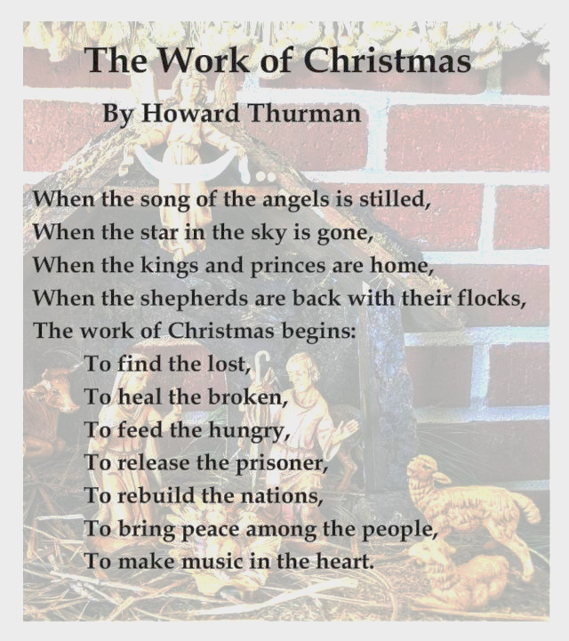

***Year End Contributions***

Please have all gifts to First United Methodist Church to the business office by **12:00 Noon** on Thursday, **December 29th**.

First United Methodist Church

324 Pineville Road

Monroeville, Alabama 36460

251-575-2790

December 25, 2022



**Church Staff**

Senior Pastor: Rev. John Woodrow

Minister of Education: Rev. Pam Barnhardt

Director of Music Ministries/Organist: Nancy Carleton

Church Business Administrator: Caroline Hardin

Nursery Director: Christi Dunn

Nursery Attendants: Letitia Gibbs & Rosie Parker

**Morning Worship**

December 25, 2022 ‡ 10:05

**Christmas Day**

**ENTRANCE**

Gathering  *Prelude* Nancy Carleton  *Welcome and Opportunities* Rev. Pam Barnhardt

Invocation Rev. Barnhardt

Offering Nancy Carleton

† Doxology *Praise God from Whom All Blessings Flow* Hymnal, 95

Hymn 246 *Joy to the World*  Congregation

**Favorite Memories, Favorite Hymns**

Hymn 224 *Good Christian Friends, Rejoice*  Congregation

† Benediction Rev. Woodrow

† Three-fold Amen Congregation

**________________________________________________________________________________________________**

† *Standing as able Please silence or turn off your cell phones.*

**Opportunities for the Week**

Sunday, December 25 **Christmas Day**

10:05 am Worship Service (Sanctuary)

- No Evening Activities -

Monday, December 26 Church Office Closed

Tuesday, December 27

Wednesday, December 28

Thursday, December 29

6:00 pm AA Meeting (Norman Barnett Hall)

Friday, December 30

Saturday, December 31

Sunday, January 1 **New Year’s Day**

10:05 am Worship Service (Sanctuary)

- No Evening Activities -

**CELEBRATING BIRTHDAYS THIS WEEK**

Virginia McQueen Charlie Martens Sue Sellers Becky Barnett

**Email: FUMC324@gmail.com**

[**www.firstumcmonroeville.org**](http://www.firstumcmonroeville.org) **Facebooklive: MonroevilleFumc-Youth**

PRAYER CONCERNS

Pray for one another that you may be healed . . . James 5:16

NEW THIS WEEK Anne Pickens

FROM OUR CHURCH Cecelia Ingram Mary Ann Brown Norma James Rosemary & Ben Johnston Jim & Janice Kane Norma James Carol Cobb

GLOBAL CONCERNS

FRIENDS & FAMILY MEMBERS James Henry *Neil Dobson*  Mike Edward *Sherry Knighten* Kaitlyn Tillman Bruce Fussell Chris Lyles Andrew Flowers Jimmy Ivey Marion Morrow

**Please note our prayer request policy:**

We cannot publish a prayer request if the person making the request has not signed the attendance form on which it is submitted.

Prayer requests will be published for 3 months unless requested otherwise.

Names in italics indicate long term needs.

It is not the intention of the staff to remove any who remain in particular need of prayer. If this occurs, please let us know so that it can be corrected.

You may add or remove names from the prayer list at any time by using the Prayer Concerns cards in the pews and placing it in the offering plate or by calling the church office.

**Attendance registration August 13, 2017**

Check one: 9:00_____11:00_____

Name___________________________

Address_________________________

Phone__________________________

Email___________________________

* Member(s)
* First time visitor
* Visitor
* Wish to join church
* Desire pastoral visit

Will you share your birthday below for our newsletter birthday list?

_______________________________

Sympathy is extended to the families of

Dan and Mike Wiggins on the death of

their Father, Daniel Wiggins,

who passed away on December 19, 2022.

*The Altar Flowers today are given to the greater glory of God*

*and*

*by Cecelia Ingram/Pam Barnhardt.*