*Silent night, holy night, all is calm, all is bright*

*Round yon virgin mother and child.*

*Holy infant, so tender and mild,*

*Sleep in heavenly peace, sleep in heavenly peace.*

*Silent night, holy night, shepherds quake at the sight;*

*Glories stream from heaven afar,*

*heavenly hosts sing Alleluia!*

*Christ the Savior is born, Christ the Savior is born!*

*Silent night, holy night, Son of God, love’s pure light;*

*Radiant beams from thy holy face*

*with the dawn of redeeming grace,*

*Jesus, Lord at thy birth, Jesus, Lord, at thy birth.*

*Silent night, holy night, wondrous star, lend thy light;*

*With the angels let us sing,*

*Alleluia to our King;*

*Christ the Savior is born, Christ the Savior is born!*

**As you depart in silence, please extinguish your candle**

**and place it in one of the holders in the Narthex.**

**After everyone has exited the Sanctuary**

**you may come back in to pick up your poinsettias.**

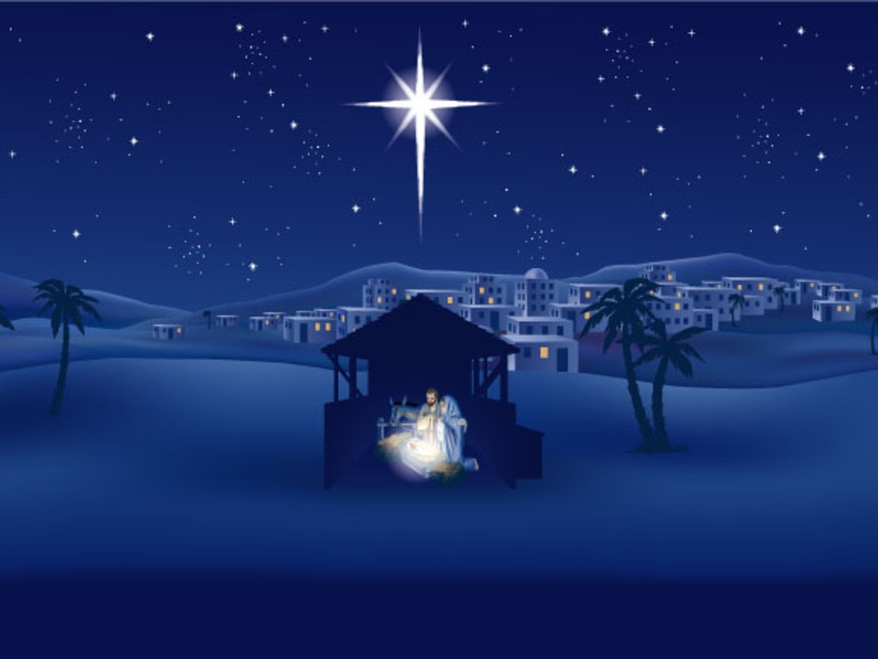

FIRST UNITED METHODIST CHURCH

324 Pineville Road • Monroeville, AL 36460

Pastoral Prayer Rev. John Woodrow

† Hymn 238 *Angels We Have Heard on High* Congregation

*(Sing all verses. Let the children come forward during the last verse)*

Children’s Moment Rev. Barnhardt

Music Ministry

Scripture *Luke 2:1-14 (KJV)* Rev. Woodrow

Sermon *“The Christmas Connection”* Rev. Woodrow

† Hymn 230  *O Little Town of Bethlehem* Congregation

**THE HOLY COMMUNION**

Communion Liturgy Rev. Woodrow & Rev. Barnhardt

Giving the Bread and Cup Servers

**THE RITUAL OF CANDLELIGHTING**

*The Ministers will light candles from the Advent Wreath.*

*The ushers will come forward to receive their light from the ministers.*

*They will then pass the flame to the person at the end of each pew,*

*who will pass it down the pew.*

*Remember, hold the lighted candle upright and tilt the unlighted candle to light it.*

† Candlelighting Hymn *Silent Night* Congregation

*(Words printed on back)*

† Comissioning & Benediction Rev. Woodrow





THE EVENING ORDER OF WORSHIP

December 24, 2022 ~ Five O’clock and Seven O’clock

**CHRISTMAS EVE**

Holy Communion

Gathering  *Prelude* Nancy Carleton

*Welcome and Invocation* Rev. Pam Barnhardt

Lighting of the Christ Candle The Craig Family (5)

The Barnhardt Family (7)

† Hymn 234 *O Come All Ye Faithful* Congregation

(Verses 1, 3, and 5)

†The Great Thanksgiving Rev. Barnhardt

The Lord be with you.

**And also with you.**

Lift up your hearts.

**We lift them up before the Lord.**

Let us give thanks to the Lord, our God.

**It is right to give thanks and praise.**

Words from the Prophet *Isaiah 9:6-7* Rev. Barnhardt

A child is born to us, a son is given to us, and authority will be on his shoulders.

He will be named Wonderful Counselor, Mighty God, Eternal Father,

Prince of Peace.

There will be vast authority and endless peace

for David’s throne and for his kingdom,

establishing and sustaining it with justice and righteousness now and forever.

The zeal of the Lord of heavenly forces will do this.







